
SOP Title: | Ecom Miss-shipped orders - RMA Process SOP
Document Storage Location: | STACS/Management/SOPs – Logistics and Warehousing | Document #: | SEASOP413v100
SOP Originator: | Ecommerce Team | Last Edited by: | Valentina Popadic
Effective Date: | 10/8/2020 | Last Edited Date: | 7/01/2021
Other: | Ecom Miss-shipped orders – RMA Process

- Purpose
  - The purpose of this SOP is to standardize the expectations Miss-shipped orders and RMA Processing.

- Scope

  - Samsung eCommerce retuns process for misshipment orders in order to keep inventory in GERP and 3PL WMS systemically and physically aligned.

- Responsibilities

  - 3PL Returns Team – start triage process and complete RMA returns
  - 3PL Inventory control Team – inventory part number changes
  - SEA Logistics – additional research on the items that require further research

- Instructions

  - Ship Scan Process
    - Scan tracking # and RMA

  - Start Triage Process

    - SKU physically received (returned item) and SKU from RMA do match but IMEI is different – RMA is processed per regular process. Item can be received in 3PL WMS system as regular RMA and all steps after that can be completed as per regular process ( put-away to regular bin location, etc.)

    - SKU physically received (returned item) is not on the RMA. - The associate places the item on the exceptions cart and notifies lead or supervisor for futher research/process.

  - Further Research - Lead or supervisor will determine if it is in fact a miss-ship and will check to ensure if physically received item was shipped out of S.Com warehouse

    - If the SKU physically received was not shipped from S.com - item is returned to the Customer(RTC).

    - If the SKU physically received was indeed shipped from S.Com warehouse - Lead/Supervisor will then check to see if the item/IMEI is associated with another order.
      - If the item was found to be associated with another order, Lead/Supervisor will do following:
        - Proces RMA “ AS IS” . This will Credit customer and increment inventory in 3PL WMS and GERP
        - Place item from the RMA on “RECMISMATC” bin location in 3PL WMS ( also separate physical bin location ( cart ) located in Returns Area ).
        - Log following information into the “ Exceptions Log “ : RMA number, SKU received in 3PL WMS and SKU physcialy received. “Exceptions Log” is shared every day with SEA Logistics ( EOS report ) and information is available for review. Example file with this information is attached on the bottom of this document.
List of all items processed as Miss-ship will be found in 3PL WMS bin location “RECMISMATC” and will have to have item that is attached to it as to show physically received unit.

      - If the item was found not to be associated with another order shipped from S.Com warehouse – SEA Logistics will need to perform further research and provide resolution.

  - PUMI
    - SEA Logistics will submit by - weekly PUMI to adjust out incorrect item from GERP inventory and therefore incerement correct item in GERP. PUMI example is attached on the bottom of this document.
    - Once Pumi is approved SEA will send request to 3PL to perform P/N transactions in 3PL WMS system. After P/N transactions are complete material can be systemically and physically placed in regular rack locations.
      - Items that are “A” stock – place into PF ( pick front ) locations
      - Items that are “B: stock – place into B stock bin locations
    - Once P/N transactions have been performed in Synapse – GERP will be adjusted accordingly. These system movements will have to be made during the same day ( before 11PM ) in order not to make impact to the stock comparison report.

GERP transactions:
      - GMP : Write off SKU systemically on the RMA
T-code MB1C
Doc. Header Text : Miss-Shipped PUMI WKXX
Movement Type:A02
Plant:S341
Storage location: WC1E
Enter

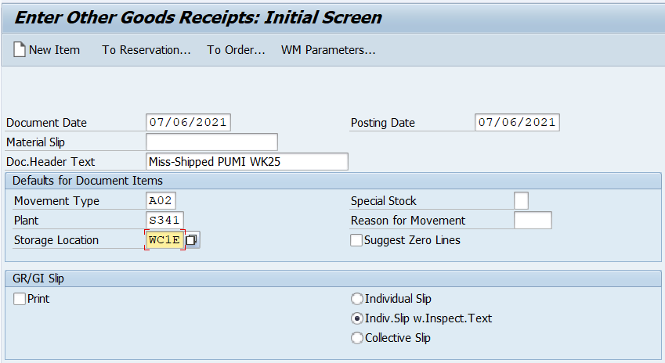
Enter the cost center for eComm : C310Z180
Fill in: Material, Quantity and Batch information in the table below and save.
Keep material document information for the records, in case inquiry made by ccounting.

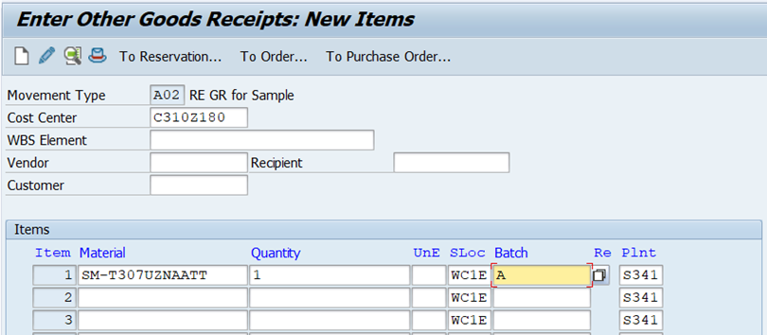

      - GMP: Write IN SKU physically received
T-code MB1C
Doc. Header Text : Miss-Shipped PUMI WKXX
Movement Type:A01
Plant:S341
Storage location: WC1E
Enter
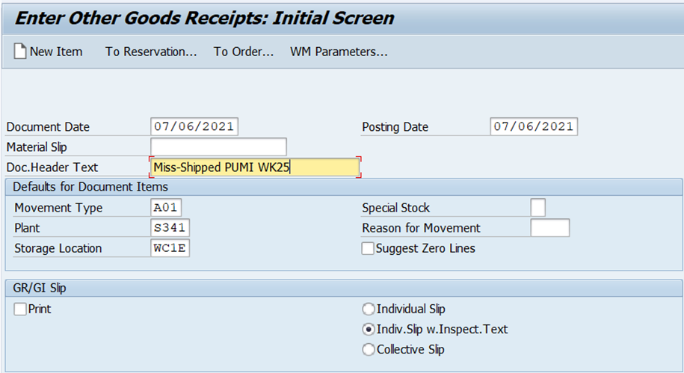

Enter the cost center for eComm : C310Z180
Fill in: Material, Quantity and Batch information in the table below and save.
Keep material document information for the records, in case inquiry made by ccounting.

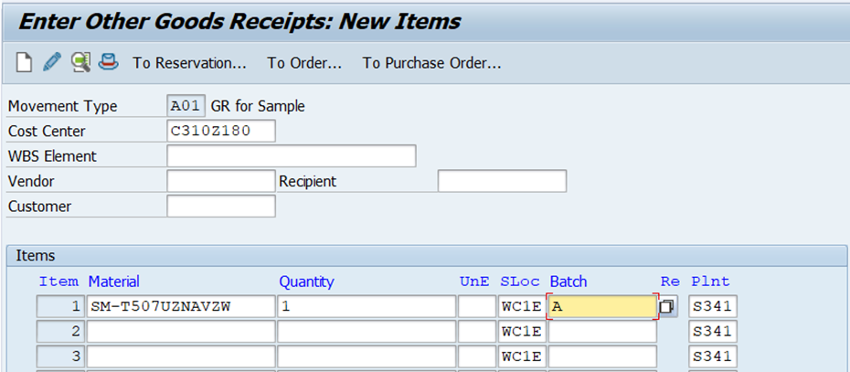

- Related Documents

File Example PUMI example

